OFF INSTALLATION ACTIVITIES
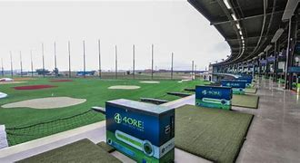
4ore Golf
Plenty of golf and additional fun (Lubbock, TX)

Subs and Stars
Enjoy a guided Goddard Planetarium Tour, then enjoy a 6" Sub-of-the-day, chips and drink. (Roswell NM)

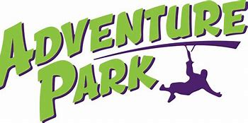
Adventure Park
Enjoy the park with the many activities. Zip Line and many more.
(Lubbock, TX)

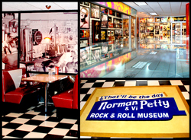
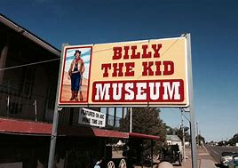
Museums
Visit the Rock n Roll and Billy the Kid Museum here in New Mexico. (Clovis NM & Ft. Sumner, NM)

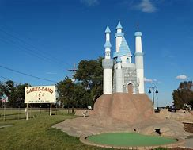
Clovis Fun Center
Enjoy the Fun Center with the many activities.
(Clovis, NM)

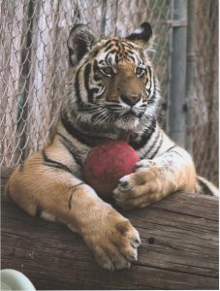
Hillcrest Zoo
Check out the furry friends at the petting zoo and the other wild animal attractions.
(Clovis, NM)

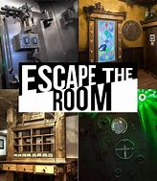
Escape Rooms
Challenge yourself and your co -workers to escape the room!
(Clovis NM & Lubbock, TX)

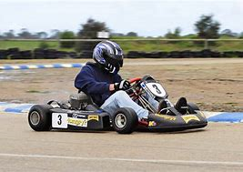
Go Carting
Vroom! Vroom! Race around the course and win the Race versus your Teammates.
(Clovis NM, Amarillo, TX & Lubbock TX)

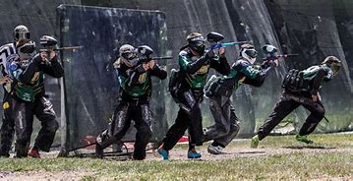
Paint Ball
Light em up !! Capture the other team’s fort and enjoy the comradery of this challenge. (Clovis NM)

Roller skating
Boogie on down! Get your groove on with Skating the time away. Try the Congo line, the limbo and other fun activities. (Clovis NM & Lubbock TX)

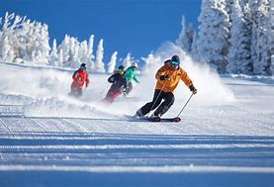
Snow Skiing
Enjoy the fresh powder by skiing or snow- boarding in NM.

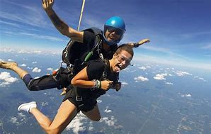
Sky Diving
Are you kidding me? Yes, you too can fly like a bird in the wild blue yonder! (Lubbock TX & Amarillo TX)

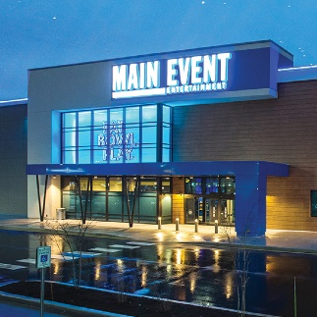
Main Event Entertainment
Bowl, play video games and enjoy the other available entertainment.
(Lubbock, TX)

Trampoline Parks
Bouncy Bouncy. Get your Tigger on at the Trampoline Park.
(Lubbock, TX)

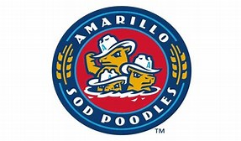
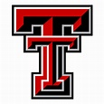
Sporting Events
Go Red Raiders and Sod poodles!
(Amarillo & Lubbock TX)

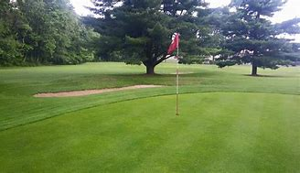
Par 3 Golf Tournament and luncheon
You can work on your short game!
(Hill Crest Park Clovis NM)

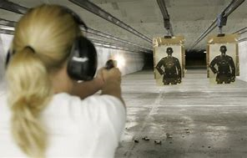
Shooting Range
Your unit can learn weapon safety and take target practice.
(Clovis NM)

ON THE INSTALLATION ACTIVITIES

Golf Tournament (Whispering Hills)
Stay on base and get a Hole in One!

Fun Runs/Amazing Race
Organize a Unit Run with any Idea in mind theme run, color run, balloon run or glow run. Be creative!

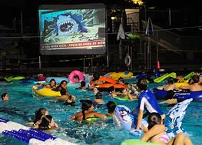
Pool Party with a Movie
Float around and watch the movie on the big screen while staying cool in the New Mexico heat!

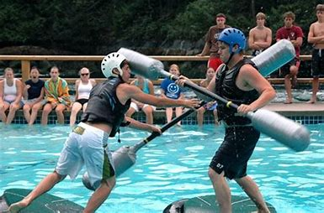
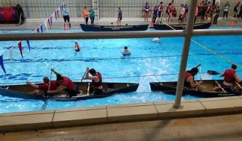
Pool Jousting/Canoe Tug a War
Enjoy the water competitions and stay cool at the same time!

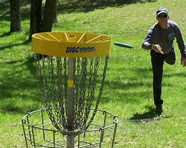
Disc Golf
Flip that disc and get a birdie, not a real one but have fun playing golf.

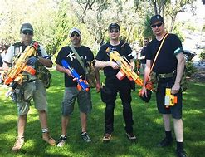
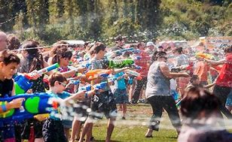
Water Gun/Nerf Gun Wars
Protect your teammates and win the battle!

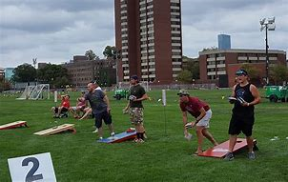
Cornhole Tournament
Slide on down and get your game on!

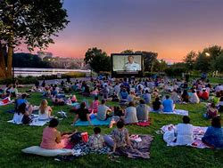
Outdoor Movie & Trivia Night
Enjoy the movie and win prizes during the trivia contest!

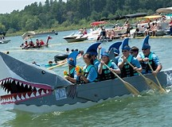
Cardboard Boat Race
Design, build it & win the Race! Or Design it, build it and sink!

Squadron Bowling
Stay on Base and get your Roll On!

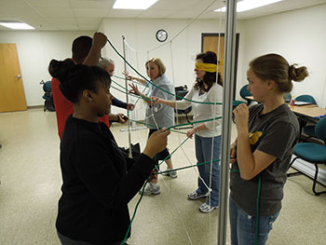
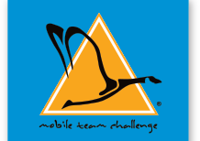
Mobile Team Challenge
Enjoy the Team challenges.

DIY Classes
Be creative! Learn how to build it paint it, and use it.

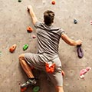
ODR Climbing Tower
ODR provides the tower and staff and you provide the excitement.

ODR Laser Tag
Zap! Help your team capture the flag.

True Colors Intnl.
Through AFRC, groups of 10-25 are optimal.

Unit Picnic and Sports Day
Rent the Pavilions and add ODR activities to your morale event.

Aero Club A & P Class
Learn how an Airplane works and how to maintain it. Take the class!

Auto Skills Basic Auto Repair Class
Increase your Auto Repair Knowledge!

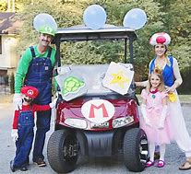
Mario Golf Carts
Enjoy the Cart Race and the team challenges!

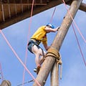
ODR Ropes Course
Enjoy the challenge, sweat and push boundaries.

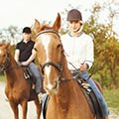
ODR Equestrian Trail Ride
Groups of 10-20 get a 1 hour ride.

ODR Outdoor Games
Various Outdoor Games to enhance your team’s morale!

ODR Mountain Bike Trail Ride
Enjoy the adventurous bike excursions in New Mexico.

VOLUNTEER OPPORTUNITIES
